

Wydział Informatyki i Zarządzania
kierunek studiów: Computer Science

Praca dyplomowa - inżynierska

Simple object state detection using camera image

Filip Drapejkowski

słowa kluczowe:
1 linia
2 linia
3 linia
krótkie streszczenie:
1 linia
2 linia
3 linia
4 linia
5 linia
6 linia

opiekun pracy  dyplomowej | .................................................. | ....................... | .......................
opiekun pracy  dyplomowej | Tytuł/stopień naukowy/imię i nazwisko | ocena | podpis

Do celów archiwalnych pracę dyplomową zakwalifikowano do:*
- kategorii A (akta wieczyste)
- kategorii BE 50 (po 50 latach podlegające ekspertyzie)
* niepotrzebne skreślić

pieczątka Instytutu, w którym student wykonywał pracę

Wrocław 2015

- Introduction
The scope of this work is process of creating a device that automatically assigns broken eggs one of the three following classes: intact yolk, damaged yolk, clear line.
The implementation of such device will be preceded with research that compares various methods of recognizing the camera image, taking into account their performance in terms of computation resources, and in terms of correctness of the recognition
- Research concerning current state of involved technologies
  - devices already using the recognition
  - recognition methods
  - market demand for a new one and potential fields of use
- Recognition algorithms
  - Preprocessing
  - Naive approaches
  - Machine Learning approach
  - Neural Networks approach (special case of Machine Learning)
  - Comparison of best results obtained with each methods
  - Choosing the algorithm
- Implementing the chosen algorithm
  - Platform - raspberry pi
  - Technical issues
  - Performance optimisation
  - Testing
- Conclusions
  - Elaboration of results
  - Beyond the scope /? Next steps (nvidia supercomputer embedded, real time) /? recommendations
- Literature

New Table of Contents
- Introduction
- Egg yolks detection
- Contaminated product recognition
- Implementation on the device

- Introduction
The scope of this work is process of creating a device that automatically assigns broken eggs one of the three following classes: intact yolk, damaged yolk, clear line.
The implementation of such device will be preceded with research that compares various methods of recognizing the camera image, taking into account their performance in terms of computation resources, and in terms of correctness of the recognition

Simple object state detection using camera image Identyfikacja stanu obiektów z wykorzystaniem obrazu z kamery

4.Implementing the chosen algorithm
  - Platform - raspberry pi
Raspberry Pi 2 Model B V1.1

  - Technical issues
Technical issues with rpi
There was a need to test raspberry pi scripts, and to satisfy it, proper input and output had to be assigned.
SSH was not sufficient, since monitoring the actual flow of egg mass on the video output enabled much easier debugging.
Nevertheless all tested video outputs - L227WT display, 27MP35 display, and EB-1761W projector displayed either ‘out of range’ error, or no image at all.
Commenting the
hdmi_mode=16
hdmi_group=1
lines in boot/config.txt file and rebooting enabled devices to work properly in VGA mode.

sudo apt-get install python-opencv

Raspberry Pi 2 Model B V1.1
-screen 0 1024x768+125+100@1

  - Raspberry Pi Camera
Raspberry Pi Camera Rev 1.3

The Raspberry Pi Camera Board Features:
Fully Compatible with all models of Raspberry Pi
Includes 150mm camera board ribbon cable
5MP Omnivision 5647 Camera Module
Still Picture Resolution: 2592 x 1944
Video: Supports 1080p @ 30fps, 720p @ 60fps and 640x480p 60/90 Recording
15-pin MIPI Camera Serial Interface - Plugs Directly into the Raspberry Pi Board
Size: 20 x 25 x 9mm
Weight 3g

Enabling camera ( http://www.pyimagesearch.com/2015/03/30/accessing-the-raspberry-pi-camera-with-opencv-and-python/ ) :
In Putty (accessing Pi via SSH)
$ sudo raspi-config
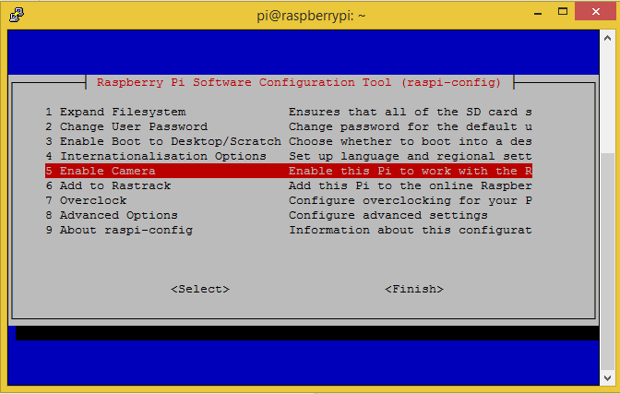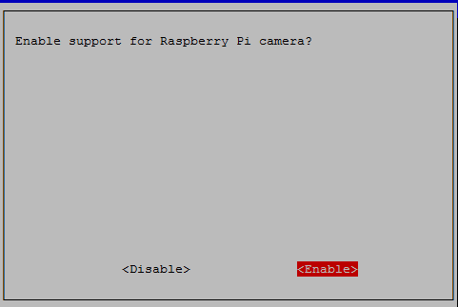

For debugging above problem -v flag was added.

pi@raspberrypi ~ $ raspistill -v -o image.jpg

raspistill Camera App v1.3.8

Width 2592, Height 1944, quality 85, filename image.jpg
Time delay 5000, Raw no
Thumbnail enabled Yes, width 64, height 48, quality 35
Link to latest frame enabled no
Full resolution preview No
Capture method : Single capture

Preview Yes, Full screen Yes
Preview window 0,0,1024,768
Opacity 255
Sharpness 0, Contrast 0, Brightness 50
Saturation 0, ISO 0, Video Stabilisation No, Exposure compensation 0
Exposure Mode 'auto', AWB Mode 'auto', Image Effect 'none'
Metering Mode 'average', Colour Effect Enabled No with U = 128, V = 128
Rotation 0, hflip No, vflip No
ROI x 0.000000, y 0.000000, w 1.000000 h 1.000000
mmal: mmal_vc_component_create: failed to create component 'vc.ril.camera' (1:ENOMEM)
mmal: mmal_component_create_core: could not create component 'vc.ril.camera' (1)
mmal: Failed to create camera component
mmal: main: Failed to create camera component
mmal: Camera is not detected. Please check carefully the camera module is installed correctly

After failing to get solution by checking http://raspberrypi.org/forums , http://raspberrypi.stackexchange.com/ and various IT blogs, the decision was made to reinstall newest raspbian.

Tried methods were:
- sudo rpi-update
- sudo- apt-get update, sudo apt-get upgrade
- assigning 256 mb insteard od 128 mb to gpu_mem in config.txt
- cleaning the conectors with spirit

While trying to put NOOBS_v1_4_2 Raspbian installer obtained from https://www.raspberrypi.org/downloads/ a problem occured - the SanDisk Ultra 8GB HC I card showed only 717MB available space.

Fix was found at:
http://www.neil-black.co.uk/recover-lost-space-from-an-sd-card#.Vi4u8berSHs
Following steps were taken:

After reinstalling Raspbian problem persisted.

Same procedure was conducted on borrowed Raspberry Pi (1) 2011.12 Unit, and camera hadn’t been detected as well, what leads to conclusion that faulty camera module might have been shipped.

Raspberry Pi Model B+ V1.2

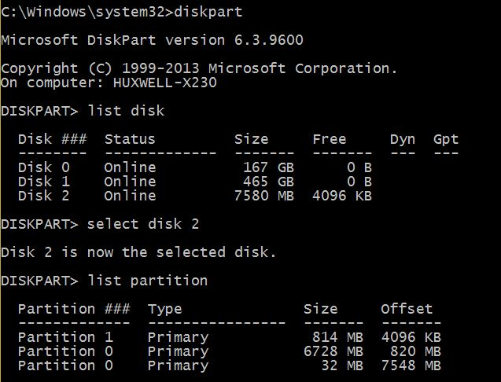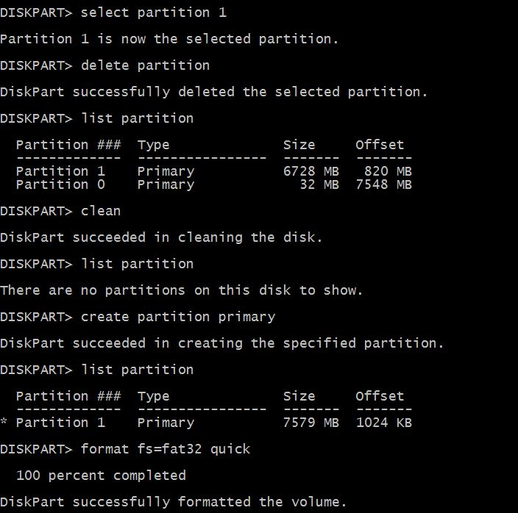

Installing OpenCV on rpi
Install OpenCV and Python your Raspberry Pi 2 and B+Shell

$ sudo apt-get update
$ sudo apt-get upgrade
$ sudo rpi-update

sudo apt-getinstall build-essential cmake pkg-config
http://www.pyimagesearch.com/2015/02/23/install-opencv-and-python-on-your-raspberry-pi-2-and-b/

$ sudo apt-get install libjpeg8-dev libtiff4-dev libjasper-dev libpng12-dev

Package libtiff4-dev is not available, but is ref erred to by another package.
This may mean that the package is missing, has been obsoleted, or
is only available from another source
However the following packages replace it:
libtiff5-dev

Some packages could not be installed. This may mean that you have
requested an impossible situation or if you are using the unstable
distribution that some required packages have not yet been created
or been moved out of Incoming.
The following information may help to resolve the situation:

The following packages have unmet dependencies:
libtiff5-dev : Depends: libjpeg-dev

sudo apt-get install libjpeg-dev libtiff5-dev libjasper-dev libpng12-dev

sudo apt-getinstall libgtk2.0-dev

sudo apt-getinstall libavcodec-dev libavformat-dev libswscale-dev libv4l-dev

sudo apt-getinstall libatlas-base-dev gfortran

$ wget https://bootstrap.pypa.io/get-pip.py
$ sudo python get-pip.py

$ sudo pip install virtualenv virtualenvwrapper
$ sudo rm -rf ~/.cache/pip
sudo nano ~/.profile/pip
Add:
# virtualenv and virtualenvwrapper
export WORKON_HOME=$HOME/.virtualenvs
source /usr/local/bin/virtualenvwrapper.sh
$source~/.profile

mkvirtualenv cv

The whole process elapses > 4h on rPi B+, and > 1h for rPi 2

python -V
Python 2.7.9
$pip install numpy

wget-O opencv-2.4.10.zip http://sourceforge.net/projects/opencvlibrary/files/opencv-unix/2.4.10/opencv-2.4.10.zip/download
$unzip opencv-2.4.10.zip
$cd opencv-2.4.10
$ mkdir build
$ cd build
$ cmake -D CMAKE_BUILD_TYPE=RELEASE -D CMAKE_INSTALL_PREFIX=/usr/local -D BUILD_NEW_PYTHON_SUPPORT=ON -D INSTALL_C_EXAMPLES=ON -D INSTALL_PYTHON_EXAMPLES=ON -DBUILD_EXAMPLES=ON ..
Make

$ sudo make install
$ sudo ldconfig

$ cd ~/.virtualenvs/cv/lib/python2.7/site-packages/
$ ln -s /usr/local/lib/python2.7/site-packages/cv2.so cv2.so
$ ln -s /usr/local/lib/python2.7/site-packages/cv.py cv.py

$ workon cv
$ python
>>> import cv2
>>>cv2.__version__
'2.4.10'
/usr/local/lib/python2.7/site-packages
/etc/profile
PATH variable

if [ "`id -u`" -eq 0 ]; then
PATH="/usr/local/sbin:/usr/local/bin:/usr/sbin:/usr/bin:/sbin:/bin"
else
PATH="/usr/local/sbin:/usr/local/bin:/usr/sbin:/usr/bin:/sbin:/bin:/usr/local/games:/usr/games"
fi
export PATH

“Gtk-WARNING **: cannot open display”
https://wiki.utdallas.edu/wiki/display/FAQ/X11+Forwarding+using+Xming+and+PuTTY
X forwarding
ubuntu-14.04.3-desktop-amd64
Sudo apt-get install xrdp
  - Performance optimisation
  - Testing

HAAR:
One more learning with backgrounds with no fuzzy egg.

5.2 Beyond the scope /? Next steps (nvidia supercomputer
RiscOS, Arch Linux port for ARM devices

6. Literature
Think Python - Allen B. Downey -2012
Learn Python the Hard Way - Zed A. Shaw (2014)
OpenCV 2 Computer Vision Application Programming Cookbook - Laganiere Robert (2011)
High Performance Python Practical Performant Programming for Humans - Micha Gorelick, Ian Ozsvald (2014)
OpenCV for Secret Agents - Joseph Howse (2015)
Raspberry Pi Cookbook for Python Programmers - Tim Cox (2014)
Pattern Recognition and Machine Learning, Christopher M. Bishop (2006)
Learning From Data, Yaser S. Abu-Mostafa, Malik Magdon-Ismail, Hsuan-Tien Lin (2012)
Foundations of Machine Learning, Mehryar Mohri, Afshin Rostamizadeh, Ameet Talwalkar (2012)

wget -P /home/pi/Desktop/ "https://github.com/Nolaan/libopencv_24/releases/download/OpenCV_2.4.11/libopencv_2.4.11.deb.zip"

dpkg -i libopencv_2.4.11.deb

$ sudo find / -name "*opencv*.py"

sudo apt-get install libopencv-dev python-opencv

pi@raspberrypi /boot $ sudo nano cmdline.txt
GNU nano 2.2.6 File: cmdline.txt Modified

dwc_otg.lpm_enable=0 console=ttyAMA0,115200 console=tty1 root=/dev/mmcblk0p6 rootfstype=ext4 elevator=deadline fsck.repair=yes rootwait
ip=169.254.1.1

2. Egg yolk detection
2.1 Methods overview
An egg yolk, when intact and fresh can be approximated with sphere which projects as circle-like shape on 2D image.
Methods presented below enable to filter out the unnecessary noise, simplify the image and detect the yolk shape.
While not all of them were used in the final detection algorithm, they were giving promising results on the early stage prototypes.

Following methods treat images as 1, 8, or 24-bit encoded matrices, thus both terms are used synonymously.
x and y denote pixel position.

2.2 Circle Hough Transform (CHT)
Circle Hough Transform is an algorithm used for retrieving 3 parameters defining a circle-like shape on images:
- (x_{c}, y_{c)} - position of shapes center
- r - its radius

To understand the way CHT works, simplified case is considered:
The image is 1-bit encoded; the radius r and position (x_{p},y_{p}) of a point lying on the searched circle are known.
Potential circles space is created by treating points on a circle of radius r centered in (x_{p},y_{p}) as centers for potential circles.
For every potential circle, number of intersecting points is counted.
The potential circle with largest number of intersections is chosen as the best fitting one.

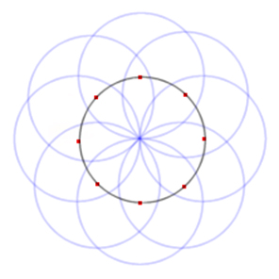
Figure 2.2.1: Potential circles space

In the full cases, such procedure is repeated for every image point, and the intersections numbers are stored in accumulation matrix.
To reduce computation time and false detection rate, minimum distance between image centers is given as a parameter min_dist.
Threshold value param_2 is defined as minimum number of intersections to treat circle candidate as detected circle.

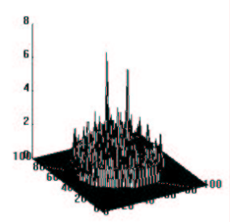
Figure 2.2.2: Accumulation matrix with two good circle candidatesError: Reference source not found

If r is unknown, min_radius and max_radius parameters are defined, and the algorithm repeats the procedure for all possible integer r in range of above parameters.
OpenCV utilizes Canny edge detector for finding the potential intersection points, thus operates not only on 1-bit images, but also in 8-bit grayscale and 24-bit bgr images and provides smaller number of false positives.
param_1 is introduced as higher threshold for Canny edge detector, while the lower threshold is set to 0.5 * param_1.

2.3 Erosion and Dilatation
Erosion and dilatation are two morphological filters that enable to filter out unnecessary noise from the image.
Combined, they leave the core information (biggest blobs) intact or amplified, while small elements are deleted.
It is easily applied to binary images:
A ROI (region of interest, a rectangular part of image) moves through image pixel by pixel and is compared to previously defined kernel (binary matrix, usually symmetric with respect to both diagonals).

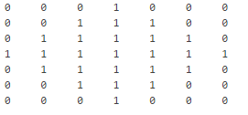
Figure 2.3.1: A diamond-shaped kernel

The consecutive pixels of on ROI that matches kernel elements with value 0 remain intact.
Pixels of ROI that matches kernel 1-valued elements changes to:
1-ns if at least one of them is 1 for Dilatation
0-s if at least one of them is 0 for Erosion.

Erosion gives the effect of ‘shrinking’ the objects (and if they are small enough, they are deleted).
Dilatation makes the objects bigger.

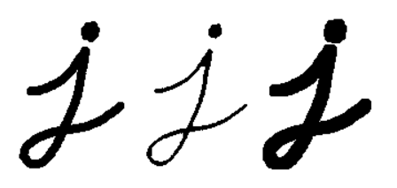
Figure 2.3.2: Orignal image, eroded image, dilated image.

When these methods are used multiple times, and convoluted, they filter out the noise.
Perimeter Determination and Skeletonization are widely used contour detection functions which utilize erosion and dilatationError: Reference source not found.

2.4 Gaussian blur

Gaussian blur is obtained by convoluting pixel with gauss function values.

It reduces noise, detail and filters out the high frequencies what makes it a low pass filter.

Gaussian blur drastically reduces number of false-positive Hough circles detections. It nevertheless should be coupled with sharpening to reduce false-negative cases.

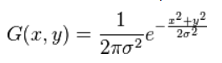
Formula 2.4.1: Gauss function in two dimension

sigma, ksize.width, ksize.height parameters are introducted.
Ksize stands for size of precomputed kernel, that is convoluted with ROIs on the image.

The term ‘convolution’ might be misleading and for the scope of image processing tasks is defined as picewise multipling two matrices and than summing the obtained values:

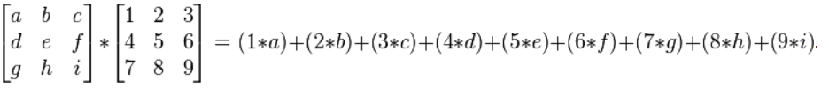

Formula 2.4.2: Convolution of 3x3 matrices
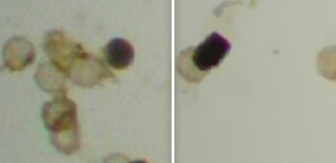
Figure 2.4.1: Microscope image before and after applying gaussian filterError: Reference source not found

2.5 Thresholding

Thresholding is a simple case of image segmentation.
It can be used to convert one channel (in most cases grayscale) image to binary image.
The basic binary thresholding mode sets every pixel of destination matrix to
0 if the source matrix value is smaller than threshold (integer parameter)
1 if the source matrix value is bigger than threshold.
The truncate version sets every pixel of destination matrix to
threshold if the source matrix value is smaller than threshold, or
leaves it unaltered otherwise.
Various modes and modifications are used depending on coding schema and colors distribution.
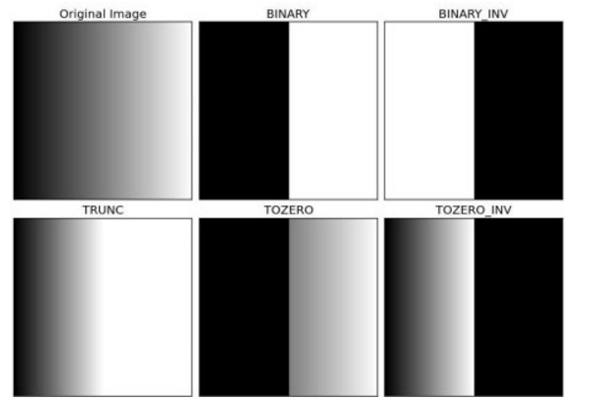
Figure 2.5.1: Different Thresholding modes
Generated with a.

]

Finding optimal threshold value finding is a time consuming process and it often gives satisfactory results only for small set of images.
Therefore Otsu Binarization algorithm for automatically selecting threshold is used.

Moreover using one threshold value for whole image may not work properly if the lighting conditions differ in different image areas.
Adaptive Thresholding utilize different threshold values for different ROIs.
Two modes are often used: Adaptive Mean and Adaptive Gaussian.
First compute threshold value as mean of neighbourhood values.
Second uses weighted sum neighbourhood values.
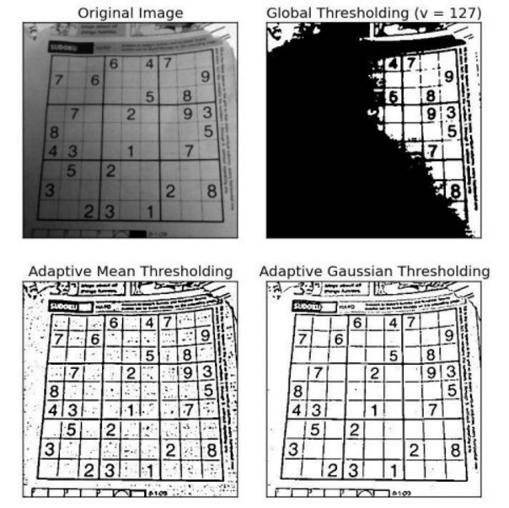
Figure 2.5.2: Threshold computing methodsError: Reference source not found
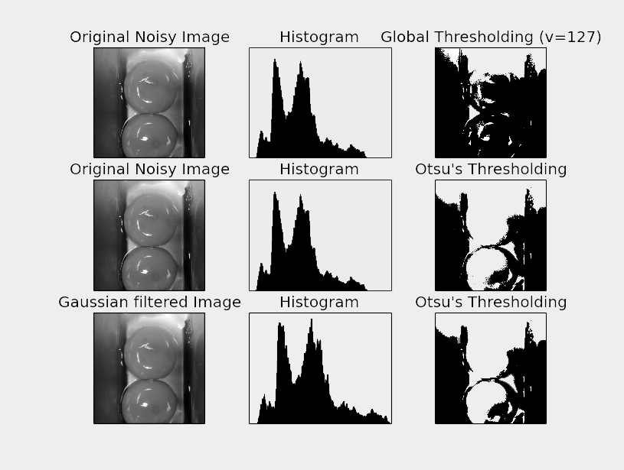
Figure 2.5.3: Different thresholding applied
Fig. generated with Metaplotlib

For more general cases (i.e. multichannel images, assigning more colors) clustering method known as k-means is widely used.
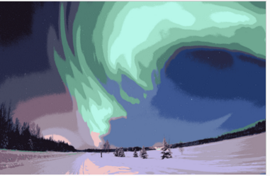
Figure 2.5.4: K-means clustering method for k = 16

2.6 Channeling and HSV conversion
2.7 Finding optimal parameter values
2.8 Overfitting
3. Contaminated product recognition

All the Web. sources have been checked for availability in November 2015.
Web links are not included if articles are to be immediately found with search engines, which is consistent to MLN referencing convention.
For modified web documents, date of last modification is shown.

C: surname, first_name_initial., “article_title” webpage_name publisher Web./Print. creation_year.

"Hough Circle Transform." OpenCV 2.4.12.0 Documentation, Opencv Dev Team, Web. 2014
Milbourne A., "Computers Counting Craters", Birkbeck College, Web. 2012
Rhody, Harvey. "Hough Circle Transform." Chester F. Carlson Center for Imaging Science Rochester Institute of Technology, Web. 2005
Kapur S., Thakkar N., “Mastering OpenCV Android Application Programming”, Pack Publishing, Print. 2015
"Feature Detection." OpenCV 2.4.12.0 Documentation, Opencv Dev Team, Web. 2014
“Morphology Fundamentals: Dilation and Erosion”, MathWorks Documentation, The MathWorks, Inc. Web. 2014
"Eroding and Dilating" OpenCV 2.4.12.0 Documentation, Opencv Dev Team, Web. 2014
Shapiro L. G., Stockman, G. C: "Computer Vision", Prentice Hall, Print. 2001
Khvedchenya E. “How to detect circles in noisy images”, Computer Vision Talks, Web. 2014
Nixon M. S. Aguado A. S., ”Feature Extraction and Image Processing”, Academic Press, Print. 2008
Lecarme O.; Delvare K., “The Book of GIMP: A Complete Guide to Nearly Everything” No Starch Press, Print. 2013
"Image Thresholding." OpenCV 2.4.12.0 Documentation, Opencv Dev Team, Web. 2014
Barghout L., Sheynin J., "Real-world scene perception and perceptual organization: Lessons from Computer Vision." Journal of Vision, Print. 2013
„Image segmentation”, Wikipedia, Wikimedia Foundation Inc, Web. 2015

